1. **Value proposition**

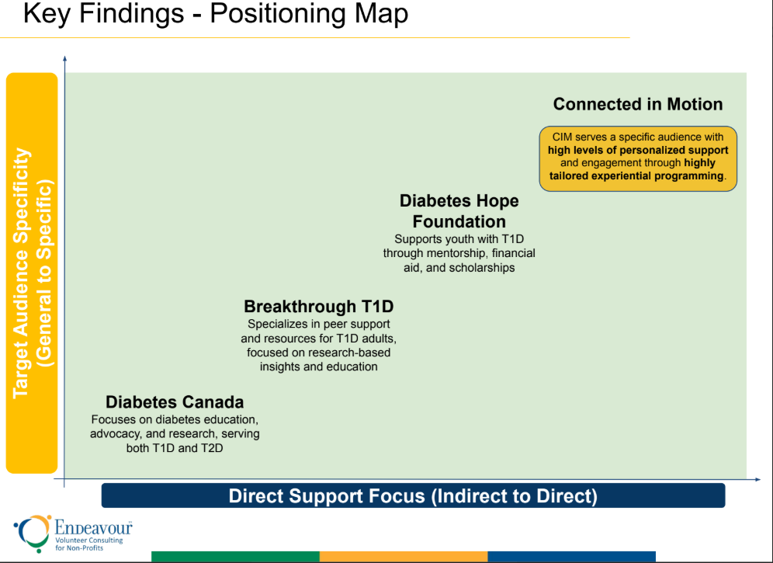

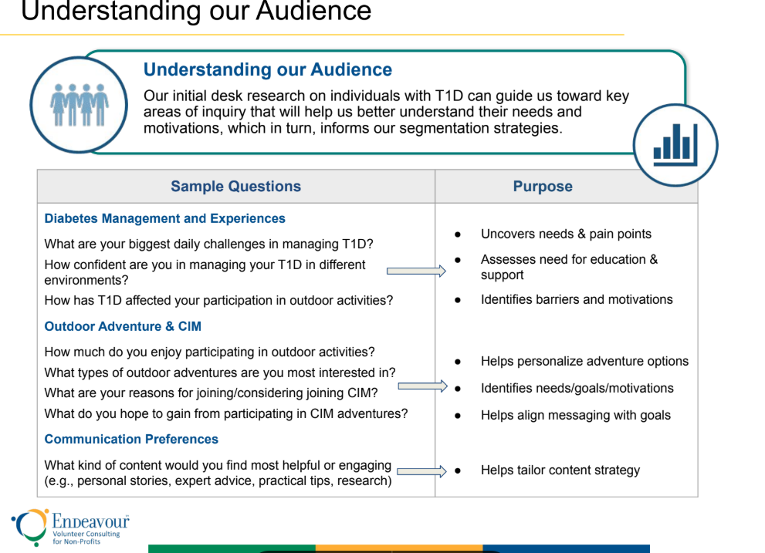

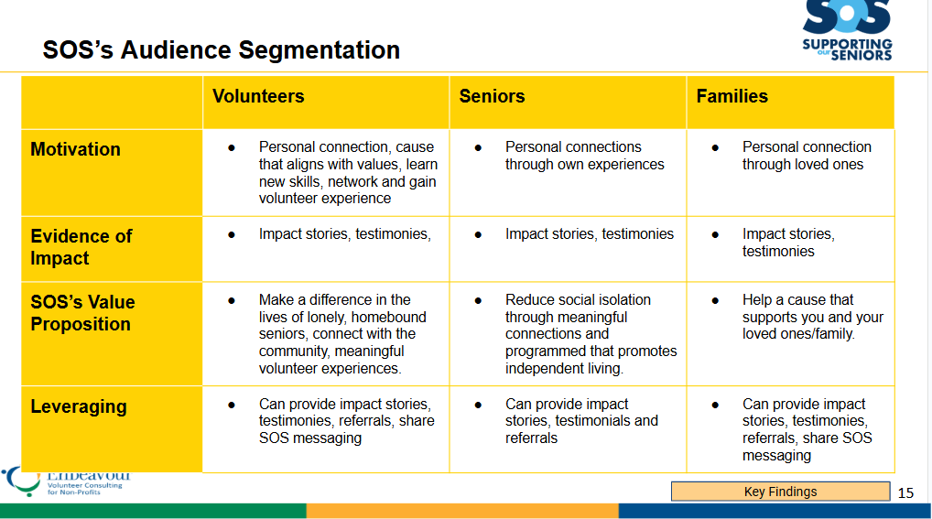

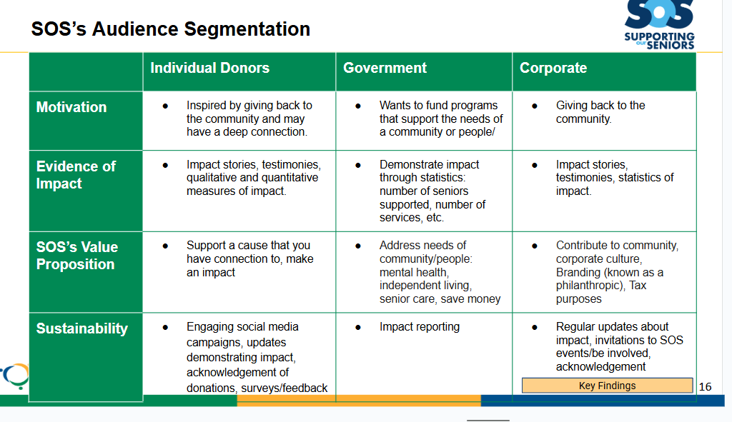

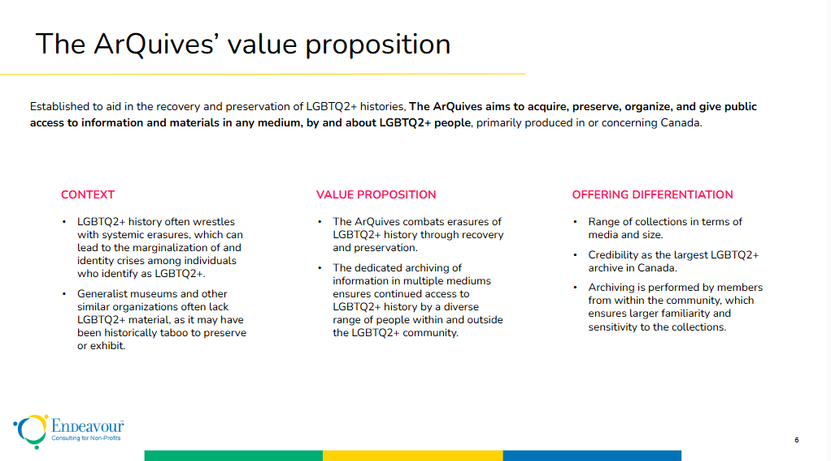

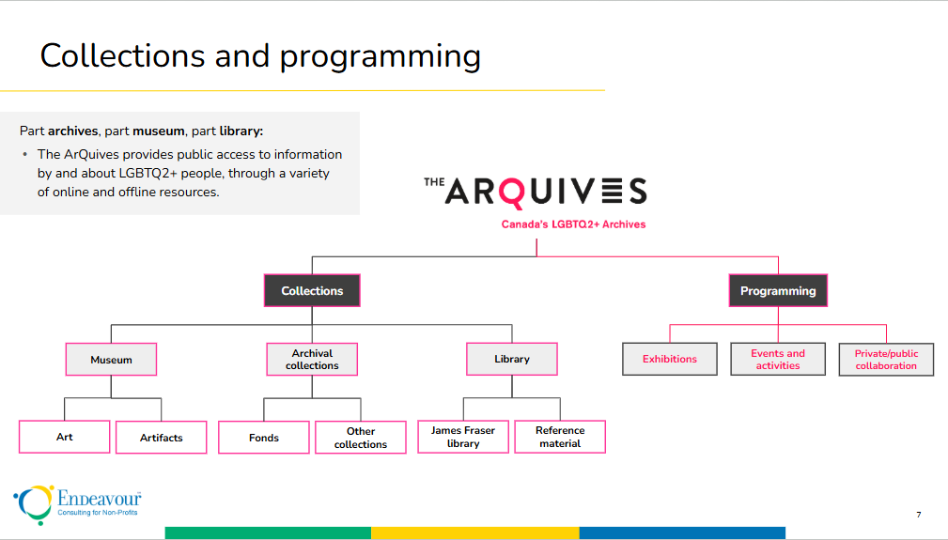

1. **Financial analysis**

**Considerations for final presentation**

* Add definitions of some of the terms used e.g., net income
* Keep the line chart on one slide; add key takeaways
* Move the figures to another slide and add one or two descriptive key takeaways
* Methodology slide
  + For the financial statements, which key numbers were pulled on
  + Client working sessions: What exactly did you inquire about? See my comments on methodology above
  + Trend analysis and projection: clearly list out the steps taken, including how the forecast was prepared